Developing Data Analytics Support for Creative

Learning Web Framework

Anand Morye  
*Department of Information Technology*  
*A.P Shah Institute of Technology*Thane, India  
19104018@apsit.edu.in

Neel Dudheliya   
*Department of Information Technology*  
*A.P Shah Institute of Technology*Thane, India  
19104049@apsit.edu.in

Prof. Jayshree Jha  
*Department of Information Technology*  
*A.P Shah Institute of Technology*Thane, India  
jpjha@apsit.edu.in Ayush Jain  
*Department of Information Technology*  
*A.P Shah Institute of Technology*Thane, India  
18104005@apsit.edu.in

*Abstract*— Online learning has grown steadily in the last two decades, and the use of learning analytics has increased in parallel. As online education continues to grow, instructors need to find new ways to enhance student learning online and to understand students’ interactions with their online learning environment. This research paper presents the design and development of an analytical tool aimed at providing instructors with visual representations of student engagement and outcomes in online learning environments. The tool was built to capture student behavior data while they interact with course content on a subscription-based online learning platform and to present this data in a visual format that is easy for instructors to understand and interpret. This data can be anything such as page per views, bounce rate, video playback rate, course completion path, etc. This tool is designed to enable instructors to identify areas of student engagement and performance in online learning environments, as well as help them better understand and respond to their students’ learning needs.

Keywords: Online learning, learning analytics, student engagement, student behavior analysis.

# Introduction

Online learning platforms have rapidly grown in popularity as a convenient and cost-effective alternative to traditional education. With the increasing demand for online education, instructors face the challenge of providing students with an engaging and effective learning experience in an online environment. To achieve this, instructors need to have a deep understanding of their students' behaviour and engagement while interacting with course content.

To address this challenge, this paper presents the design and development of an analytical tool aimed at providing instructors with insights into student behaviour and engagement in online learning platforms. The tool was built to collect data on students' interactions with course content, feedback, and performance, and to present this data in a visual format that is easy for instructors to understand and interpret. This tool provides instructors with a comprehensive analysis of student behaviour and engagement, allowing them to make informed decisions about their course content and structure, leading to improved student engagement and outcomes.

The goal of this research was to provide instructors with a practical and effective tool that could help them to better understand their students and improve the quality of education delivered through online learning platforms. The tool has the potential to significantly impact the quality of education delivered through online learning platforms, by providing instructors with valuable insights into student behaviour and engagement. The development of this tool represents an important step towards providing instructors with the tools they need to succeed in the rapidly growing online learning industry.

Furthermore, this analytical tool can provide instructors with a wealth of information about student behaviour, including: the average time spent on each section of the course, the number of students who complete the course, the most popular sections of the course, the average score on assessments, and the types of feedback provided by students. With this information, instructors can make informed decisions about the course structure and content, including which sections to keep or remove, which sections to modify, and which sections to add. By using this tool, instructors can improve student engagement and satisfaction, and provide a better overall learning experience for students.

# Objectives

We intend to achieve the following objectives in our project.

* To gather and analyse data on student behaviour and engagement in online learning platforms to identify patterns and trends.
* To provide instructors with real-time insights into student behaviour and engagement, allowing them to make adjustments to their course content and structure in real-time.
* To present the collected data in a visual format that is easy for instructors to understand and interpret
* To enhance the transparency and accountability of online learning platforms by providing instructors with data-driven feedback on their course content and structure.
* To support the development of personalised and adaptive learning experiences in online education, by providing instructors with data-driven insights into student behaviour and learning needs.

# Literature review

The purpose of literature review is to gain an understanding of the existing research on Learning analysis on MOOC based platforms. This research helped us understand the current limitations on social interactions in online learning and how they affect student motivation and performance. It also helped us determine the data requirements.

According to Prince, Michael & Felder, Richard & Brent, Rebecca [1], student engagement is a critical factor in the success of online courses and that it is essential to provide an engaging and interactive environment for students. The authors highlight the importance of designing course content that is engaging and relevant to students, using a variety of media, including videos, animations, and simulations. The paper provides specific recommendations for promoting student engagement, including the use of interactive activities such as virtual labs, case studies, and problem-based learning. The authors suggest that instructors should also provide opportunities for students to apply their learning in real-world situations and to connect with professionals in their field.

Heilporn, Géraldine & Lakhal, Sawsen & Belisle, Marilou [2] examines the effects of different instructional strategies on student engagement in blended online courses. Blended online courses refer to a combination of online and face-to-face instruction, where students are engaged in a mix of online activities and traditional classroom activities. The purpose of the study was to determine which instructional strategies are most effective in promoting student engagement in blended online courses. The authors reviewed existing literature and surveyed students and instructors to gather data on the use of instructional strategies and the level of student engagement. The results showed that instructional strategies that promote interaction and collaboration, such as discussion forums and group projects, are most effective in promoting student engagement. Additionally, the use of technology, such as video lectures and multimedia presentations, was also found to enhance student engagement. The authors concluded that instructional strategies that promote interaction, collaboration, and technology use are crucial in promoting student engagement in blended online courses.

Leitner, Philipp & Maier, Karin & Ebner, Martin [3] discusses the use of web analytics as an extension for a learning analytics dashboard on a massive open online platform. The authors highlight the need for a comprehensive learning analytics dashboard that provides instructors with real-time insights into student behaviour and performance. The authors propose that web analytics can be used to enhance the functionality of a learning analytics dashboard, providing additional data on student engagement, interaction, and behaviour. The authors present a case study of a massive open online platform that integrated web analytics with a learning analytics dashboard to provide a more comprehensive view of student activity. The results showed that the use of web analytics in conjunction with a learning analytics dashboard improved instructors' understanding of student behaviour and allowed them to make more informed decisions about course design and delivery. The authors conclude that web analytics can be an effective tool for improving student engagement and outcomes in massive open online platforms.

Dhumantarao, Thammi Raju & Murthy, G.R.K. & Khade, Shrikant & Padmaja, B. & Bs, Yashavanth & Kumar, S. & Soam, Sudhir & Ch, Srinivasrao [4] explores the use of learning analytics to understand learner behaviour in online courses. The authors note that online courses offer a wealth of data on student behaviour, but that this data is often underutilized. The authors argue that learning analytics can be used to make sense of this data and provide insights into how students engage with course content, interact with their peers, and use technology. The authors present a case study of an online course that used learning analytics to track student behaviour and provide feedback to instructors on areas where students struggled or engaged. The results showed that learning analytics provided valuable insights into student behaviour, allowing instructors to make data-driven decisions about course design and delivery. The authors conclude that learning analytics can be a valuable tool for improving student engagement and outcomes in online courses.

Gray, Julie & Diloreto, Melanie [5] focuses on analysing the cognitive engagement of students in e-learning discussion forums through content analysis. The authors argue that cognitive engagement is an important factor in e-learning, as it is related to students' motivation, learning outcomes, and satisfaction. To examine students' cognitive engagement, the authors conducted a content analysis of students' participation in discussion forums in an online course. The authors identified several dimensions of cognitive engagement (e.g. critical thinking, creativity, collaboration) and used these dimensions to analyse the content of students' posts in the discussion forums. The authors found that students demonstrated varying levels of cognitive engagement in the discussion forums and that this engagement was related to their learning outcomes. The authors conclude that content analysis can be a useful tool for examining students' cognitive engagement in e-learning environments and suggest that further research is needed to examine the relationship between cognitive engagement and learning outcomes in online courses.

İ. Yıldırım and S. Çırak-kurt [6] conducts a systematic review of existing research to investigate the impact of gamification on student engagement in online learning. The authors analyse studies that use gamification techniques, such as rewards and challenges, in online courses and evaluate their effectiveness in increasing student engagement. The results of the review suggest that gamification has a positive impact on student engagement in online learning, particularly in terms of increasing motivation and interest. However, the authors note that more research is needed to fully understand the impact of gamification on student engagement and to identify the most effective gamification strategies for different types of online courses.

X. Solé-Beteta, J. Navarro, B. Gajšek, A. Guadagni, and A. Zaballos [7] focuses on using data-driven methods to quantify and measure the level of engagement of students in synchronous virtual learning environments. The authors aim to develop a robust model that can accurately capture student engagement and use this information to improve the quality of online learning experiences. The study uses a combination of log data and self-reported surveys to gather information on students’ engagement levels during virtual learning sessions. The authors then analyse the collected data and develop a model that incorporates various engagement indicators such as participation, interaction, and motivation. The results show that the model is capable of accurately measuring student engagement in synchronous virtual learning environments and can be used to inform the design and delivery of online courses.

Altuwairqi, K., Jarraya, S.K., Allinjawi [8] discusses the importance of measuring engagement levels of students in online learning environments. The paper proposes a framework that incorporates learning analytics to analyse student behaviour and engagement in online courses. The framework uses a variety of data sources, including clickstream data, forum posts, and grades, to measure engagement levels. The paper highlights the benefits of using learning analytics for student engagement, such as identifying at-risk students and providing targeted interventions, and also discusses the challenges of implementing learning analytics in higher education, such as data privacy concerns and ethical considerations. Overall, the paper provides a valuable contribution to the field of online education and learning analytics by highlighting the importance of student engagement and providing a framework for measuring it.

Czerkawski, B.C., Lyman, E.W [9], discusses an instructional design framework to enhance student engagement in online learning environments. The authors highlight the challenges that educators face while designing and delivering effective online courses and the importance of engaging students for their success in such environments. The paper discusses the key components of the proposed framework, including the course content, instructional strategies, and technology used to create the course. The authors also discuss the importance of understanding the learners' characteristics and motivation for learning, and how this can be leveraged to design more effective online courses.

# Problem definition

The problem that this project aims to address is the lack of visibility and insights into student requirements in online learning platforms. Currently, instructors are often unable to see how students are interacting with their courses, what aspects of the course are most popular, and where students may be struggling. This lack of information makes it difficult for instructors to improve their courses and better engage their students.

One of the main challenges in this area is the sheer amount of data that is generated by online learning platforms, and the difficulty in making sense of this data in a way that is useful for instructors. The data is often stored in disparate systems and is not easily accessible or comparable, making it difficult to draw meaningful insights. Furthermore, the traditional methods of collecting data on student interactions, such as surveys and questionnaires, can be time-consuming and often result in low response rates. This makes it difficult to get a comprehensive picture of student behaviour and limits the ability of instructors to make decisions about how to improve their courses.

By building an analytical tool to capture and analyse data on student behaviour and engagement in online learning platforms, this project aims to provide instructors with the insights and recommendations they need to improve their courses and better engage their students. The tool will make it easier for instructors to see how students are interacting with their courses, what aspects of the course are most popular, and where students may be struggling. This will help instructors to make data-driven decisions about how to improve their courses and create a more engaging and effective learning experience for their students.

# Methodology

## Proposed System/ Architecture

The initial step of data collection requires DOM manipulation and event management to capture student interactions on the website. Javascript is the predominant language used for the front-end task. The collected data is then parsed at the backend and stored in a database for further analysis and reporting. To be able to effectively store the data in the backend, frameworks such as Node.js and MongoDB are employed for the purpose of developing and deploying secure APIs. For our instructor dashboard, we are using chartjs, a JavaScript library that provides dynamic and interactive visualizations.

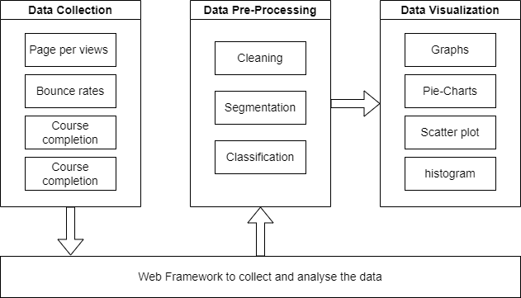

1. Proposed system Architecture

* Data Collection: The first step is to collect data on student behaviour and engagement in online learning platforms. This data can be gathered through various methods, including tracking student activity within the platform, gathering feedback from students through surveys and questionnaires, and analysing student performance on assessments and other course-related activities.
* Data Cleaning and Pre-processing: Once the data is collected, it must be cleaned and pre-processed to ensure that it is ready for analysis. This may involve removing any irrelevant or redundant data, transforming the data into a format that is suitable for analysis, and normalizing the data to ensure that it is consistent and comparable across all students and courses.
* Data Analysis: The next step is to analyse the data to identify patterns and trends in student behaviour and engagement. This can be done through a variety of methods, including descriptive statistics, inferential statistics, and visualization techniques.
* Data Visualization: The results of the data analysis must then be visualized in a way that is easy for instructors to understand and interpret. This can be done through the use of various visualization techniques, such as bar graphs, pie charts, line graphs, and scatter plots.
* Recommendations and Feedback: Based on the results of the data analysis, the tool will provide instructors with recommendations and feedback on their course content and structure. These recommendations will be based on the data collected and analysed, and will help instructors to make informed decisions about how to improve their courses and better engage their students.

## Metrics for Data Collection

Some of the metrics that we used to measure student interactions with the course materials are provided below. Additional metrics might be implemented based on requirements.

* Course Completion Rates: One of the most straightforward ways to measure student engagement is by tracking the number of students who complete a course. This can be done by tracking the percentage of students who complete the course compared to the total number of students who enrolled.
* Time Spent on Course Materials: Another way to measure student engagement is by tracking the amount of time students spend on different sections of the course. This information can be used to identify which parts of the course are the most engaging and which parts may need improvement.
* Student path through course modules: The path that the student takes to complete the course may differ from the traditional path set by the instructor. Because the student might already know the basics and want to learn advanced modules, he skips the initial topics. This can help instructors determine how to set the difficulty level of the course to better match the target audience.
* Video Playback Rates: In online learning platforms that incorporate video content, tracking video playback rates can provide valuable insights into student engagement. This information can be used to identify which parts of the video are the most engaging, and which parts may need improvement.
* Progress Tracking: By tracking the progress of students through the course, instructors can gain insights into which sections of the course are causing difficulties for students. This information can be used to improve the course design and content to make it more engaging and accessible to students.
* Analytics: Normal metrics, but for course pages, such as page views per visit, bounce rate, and user interactions with websites This will make it easier to give educators more individualized analytics.

# Result

By using this analytical tool, we were able to capture valuable data on students' behavior and performance in online courses. We used the metrics defined in the methodology to determine the data requirements. Based on the data collected, instructors can identify areas of the course where students were less engaged and make targeted improvements to increase engagement. For example, a useful metric is course conversion, which is determined by comparing total course page visits against the course enrollment.

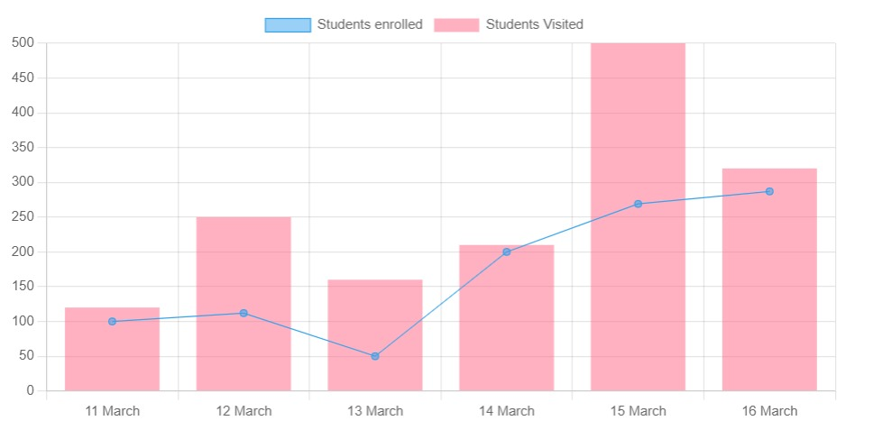

1. Course Conversion

In the above figure the blue line denotes the number of students enrolled to the course against the number of page visits represented in pink bar chart. This metric can help instructors understand whether the first impression of course is good enough. We can also monitor the interactions of students with the course material. If the material contains video lectures we can capture multimedia events such as pause, play, skip, etc. An example of Seektime is given below Seektime is the part or time of the video where the students skips to.

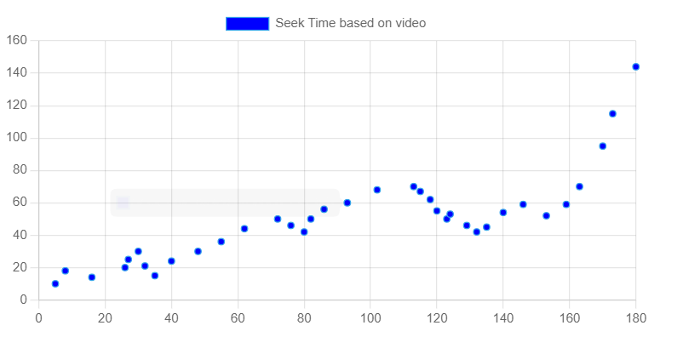

1. Video Seek Time

The X-axis represents the time in seconds concerning the video and Y-axis represents the number of times the video was skipped. One interesting finding from the data is that there is a significant increase in seek time rates towards the end of the video. This can be attributed to a variety of factors, such as the complexity of the content being covered towards the end of the video, students losing interest or attention as the video progresses, or technical issues such as buffering or poor video quality. By understanding where students tend to skip or seek ahead in a video, course creators can make targeted improvements to the content and delivery to improve engagement and retention among students. We can also check which module is popular among students to complete first in a course. The following figure represents that data using a pie chart.

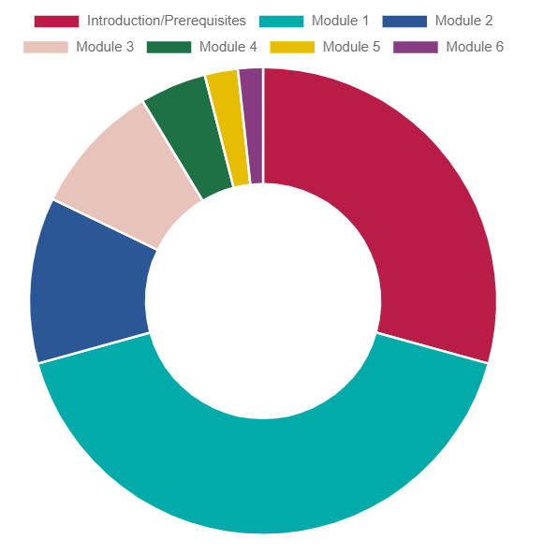

1. Module Popularity Chart

The chart represents the distribution of modules that are completed first in the course. This can help instructors better understand student requirements from the course. For instance, in the above example “Module 1” has the highest rate of completion which means majority of students are familiar with the prerequisites and introductory material

##### Future Scope

As the use of online learning platforms continues to rise, there is significant potential for further development of this project. One important consideration is the exponential growth of data collected by such applications, which can make decision-making for instructors challenging. To address this issue, predictive analysis techniques can be implemented to reduce overhead for end users and provide filtered results based on relevant metrics, such as course popularity, student engagement, and completion rates. Ultimately, the future scope of this project is vast, and could involve a wide range of data-driven metrics and personalized learning tools. By leveraging the power of online learning platforms and advanced analytics techniques, it is possible to create more engaging and effective educational experiences for students, while also providing instructors with the insights they need to make data-driven decisions and continually improve their teaching strategies.

##### Conclusion

Overall, the development of an analytical tool to capture student interactions with online learning platforms represents a crucial step towards improving the learning experience for students. By providing instructors with valuable insights into how students interact with their courses, this tool can enable them to make data-driven decisions on how to improve the course content and delivery methods. As a result, the use of learning analytics has the potential to revolutionize the way we approach online learning and increase student engagement and performance in the process.

##### References

1. Prince, Michael & Felder, Richard & Brent, Rebecca. (2020). ACTIVE STUDENT ENGAGEMENT IN ONLINE STEM CLASSES: APPROACHES AND RECOMMENDATIONS. Advances in Engineering Education. 8.
2. Heilporn, Géraldine & Lakhal, Sawsen & Belisle, Marilou. (2022). Examining effects of instructional strategies on student engagement in blended online courses. Journal of Computer Assisted Learning. 38. 10.1111/jcal.12701.
3. Leitner, Philipp & Maier, Karin & Ebner, Martin. (2020). Web Analytics as Extension for a Learning Analytics Dashboard of a Massive Open Online Platform. 10.1007/978-3-030-47392-1_19.
4. Dhumantarao, Thammi Raju & Murthy, G.R.K. & Khade, Shrikant & Padmaja, B. & Bs, Yashavanth & Kumar, S. & Soam, Sudhir & Ch, Srinivasrao. (2021). Understanding Learner Behaviour in Online Courses through Learning Analytics. Asian Journal of Agricultural Extension, Economics & Sociology. 381-390. 10.9734/ajaees/2021/v39i1030705.
5. Gray, Julie & Diloreto, Melanie. (2016). The Effects of Student Engagement, Student Satisfaction, and Perceived Learning in Online Learning Environments. International Journal of Educational Leadership Preparation. 11. 89-119.
6. İ. Yıldırım and S. Çırak-kurt , "The Effect of Gamification on Learner Motivation: A Meta-Analysis Study", Education Reform Journal, vol. 7, no. 1, pp. 1-15, Jun. 2022
7. X. Solé-Beteta, J. Navarro, B. Gajšek, A. Guadagni, and A. Zaballos, “A Data-Driven Approach to Quantify and Measure Students’ Engagement in Synchronous Virtual Learning Environments,” Sensors, vol. 22, no. 9, p. 3294, Apr. 2022, doi: 10.3390/s22093294.

[8] Altuwairqi, K., Jarraya, S.K., Allinjawi, A. et al. Student behavior analysis to measure engagement levels in online learning environments. SIViP 15, 1387–1395 (2021).

[9] Czerkawski, B.C., Lyman, E.W. An Instructional Design Framework for Fostering Student Engagement in Online Learning Environments. TechTrends 60, 532–539 (2016).

[10] M.A. Chatti, A.L. Dyckhoff, U. Schroeder, and H. Thüs, A reference model for Leaning analytics, link for the paper is provided below https://www.thues.com/upload/pdf/2012/CDST12_IJTEL.pdf

[11] Learning analytics best practices and a quick guide to build one https://www.xenonstack.com/insights/what-is-learning-analytics

[12] A Case Study on How to create the learning analytics platfrom https://ddi-dev.com/blog/case/how-to-create-the-learning-analytics-platform-from-scratch/